_________________________________________________________________________________________________________________

**22nd Annual**

**Jamison Friendsgiving Feast**

Dear Parents/Guardians/Community November 14, 2023

Please join us for our 22nd Annual Friendsgiving Feast at Robert Jamison.

The students and staff of all Grades would like to invite you to celebrate Friendsgiving at school with us on Monday, November 20th, 2023, with a Community FEAST.

On Monday, Nov. 20th, we would like to have a Friendsgiving Feast at the school. We will collect food in the Main Office & ART Room on *November 20th by 1pm. We are asking families/community members to donate a traditional Thanksgiving dish that you serve on Thanksgiving Day or any food item* (ex. can goods) for our feast. There will be about 380 students eating. We will be filling our plates in the art room and then be eating in the classrooms. Each year is a great success and we all have a wonderful time. Parents/guardians are welcome to come and help us serve the children and then enjoy all the great eats with us.

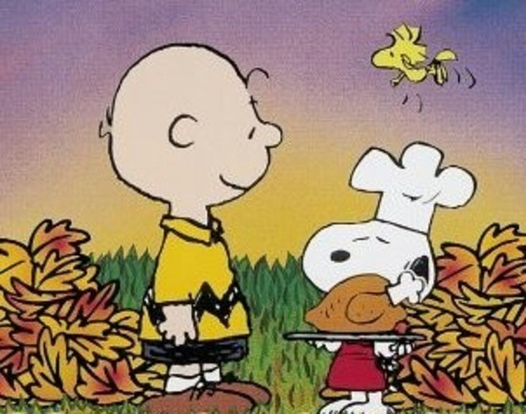Please mark down the dish you would like to share with us for the feast and return this sheet to the school by Friday 11/17th (Ms. Board/Ms. Dillon)

Please bring your dish in on Monday, Nov. 20th by 1pm and give to Ms. Board in the Main Office or Ms. Dillon in the Art Room.

Thank you, The Jamison Student Events Team & FACE Team

Return this bottom part by Friday 11/17/2023.

Scholar’s Name (s) _________________________ Room number ______________

Parent’s Name_____________________________ Phone Number ______________

______ turkey ______ pie (_____) ______ potatoes (_________________)

______ ham ______ mac & cheese ______ vegetables (_______________)

______ drinks ______ cranberry sauce ______ cookies

______ rolls/biscuits _______ butter ______ cupcakes

______ cranberries _______cornbread ______ Pie (____________________)

______ can goods _______ Juice (single serving) ______ water bottles (single serving)

___________ Other desserts __________________________________________________________________

___________ other meats _____________________________________________________________________